Setting up a Zoho Creator Account and Exploring The Platform Architecture and Interface
SAI PRANAV B.V.
241401088 CSBS

Introduction
Zoho Creator is a low-code application development platform that allows business applications to be built using visual, drag-and-drop tools combined with AI assistance, rather than hand-written code. This report documents a hands-on exploration of the Zoho Creator account and platform interface, covering the account setup process and a walkthrough of its three core functional areas: Develop, Deploy, and Manage.
Each section below pairs a screenshot captured directly from the platform with a short explanation of the corresponding feature, its purpose, and where it fits into the overall application lifecycle — from building an app, to deploying it, to managing it responsibly once live.

Zoho Creator Platform Architecture
Before walking through the interface step by step, it helps to see how Zoho Creator is structured underneath. The platform is organized into distinct layers that work together to take an application from user access all the way to deployment. The diagram below summarizes this layered architecture, based on the modules encountered during account setup and exploration.
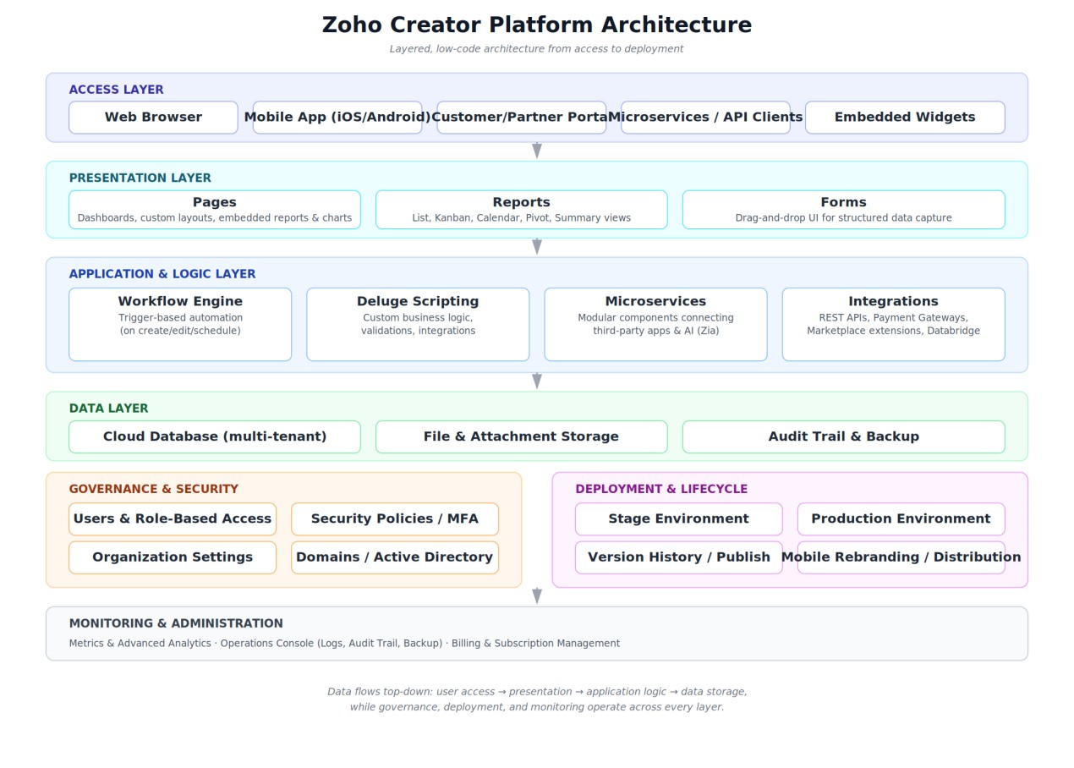
Figure 0: Zoho Creator platform architecture, from access to deployment
At the top, the Access Layer covers every way users reach an app — browser, mobile app,
customer/partner portal, or API/microservice calls. Beneath that, the Presentation Layer (Pages, Reports, Forms) is what users actually see and interact with. The Application & Logic Layer is where the platform's low-code power lives: a Workflow Engine and Deluge scripting handle automation and validation, while Microservices and Integrations connect the app to third-party services, payment gateways, and AI (Zia). All of this reads from and writes to the Data Layer — the cloud database, file storage, and audit/backup systems.
Running alongside these layers are two cross-cutting concerns visible throughout the platform: Governance & Security (users, roles, security policies, domains) and Deployment & Lifecycle (Stage and Production environments, version history, and mobile app distribution). A final Monitoring & Administration layer — Metrics, Operations, and Billing — gives account owners visibility and control over the whole system. The screenshots that follow trace this architecture in action, starting from account setup and moving through each of these layers in turn.

Application Dashboard
After signing in, the platform opens to the Applications dashboard under the Develop menu. Every card on this screen represents a Solution - a complete business application - that has been created in the account. In this exploration, one sample application, "My First Creator App," appears on the dashboard, confirming that a working Solution has already been initialized. The prominent "Create Application" button in the top right is the starting point for building any new app on the platform.
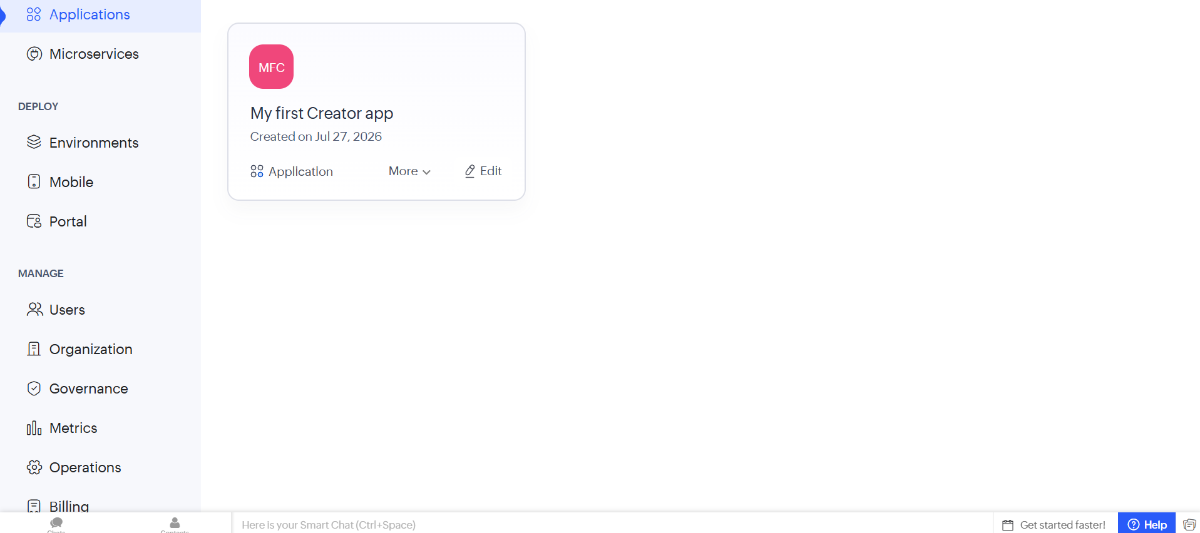
Figure 1: Application Dashboard screen in Zoho Creator

Microservices
The Microservices tab, also under Develop, is shown here in its empty state, since no microservices have been created yet in this account. A Microservice is a small, independent, and reusable unit of backend logic - such as a shared tax-calculation function or a common authentication check - that can be called from multiple Solutions instead of being rebuilt inside each one. This mirrors the idea of a function library in traditional programming: logic is written once and reused wherever it is needed.
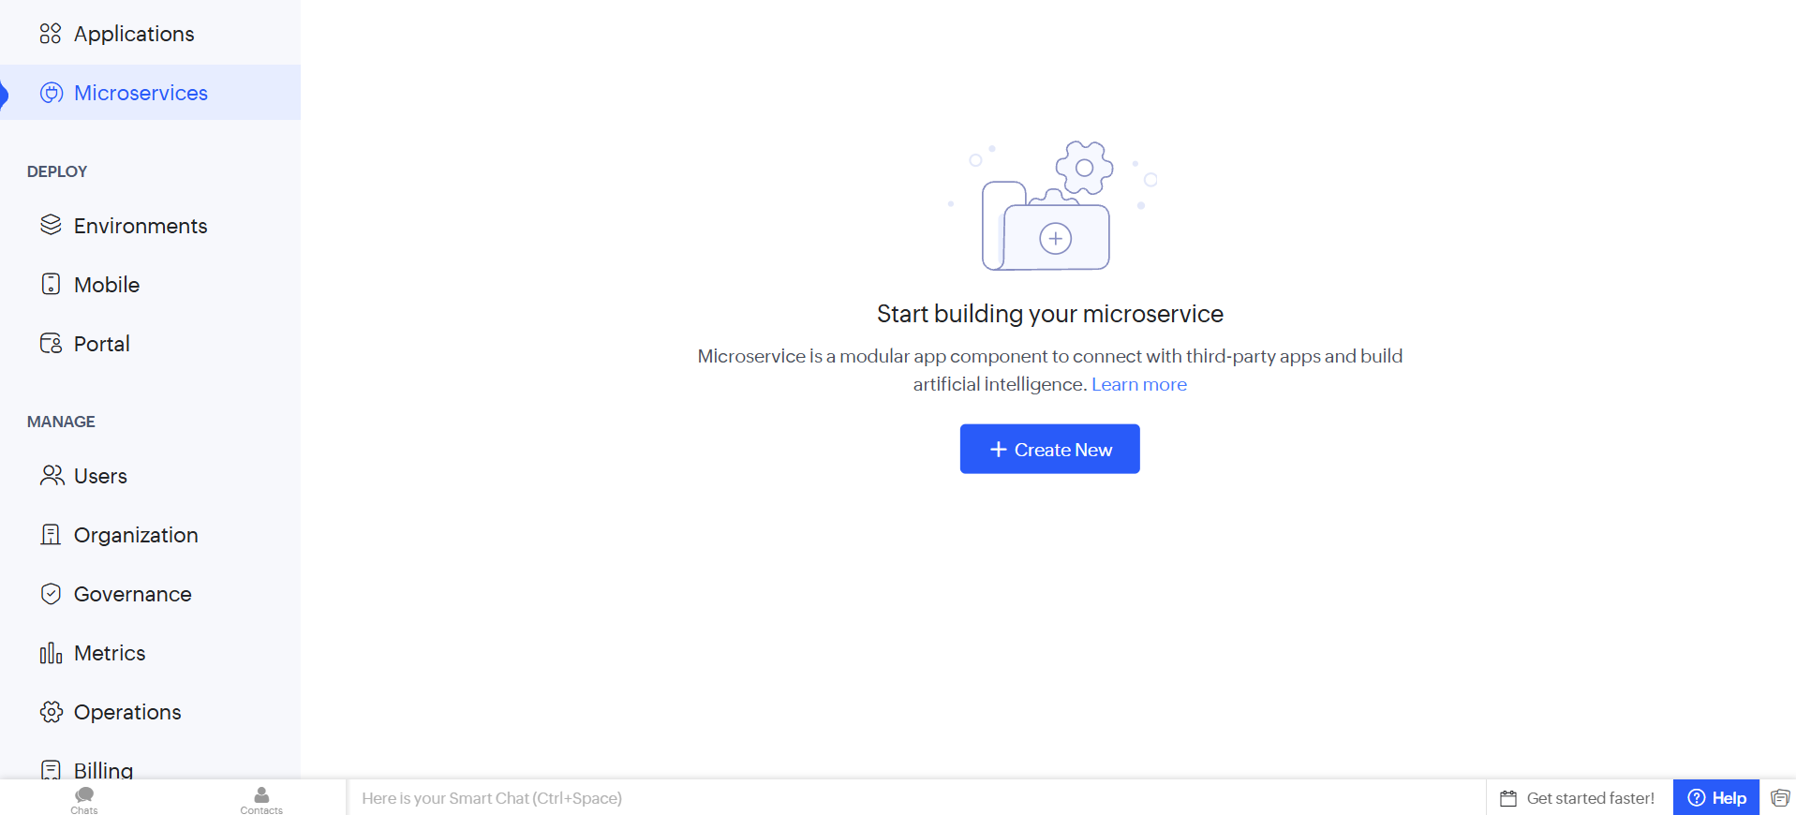
Figure 2: Microservices screen in Zoho Creato

Environments
The Environments screen, found under Deploy, organizes an application's lifecycle into separate stages. This account currently shows two environments - Stage and Production - with no applications published to either yet. In practice, the Development environment is where features are actively built and changed, Stage (or Testing) is where the app is verified before release, and Production is the live version used by real end users. Keeping these stages separate prevents unfinished changes from affecting people already using the app.
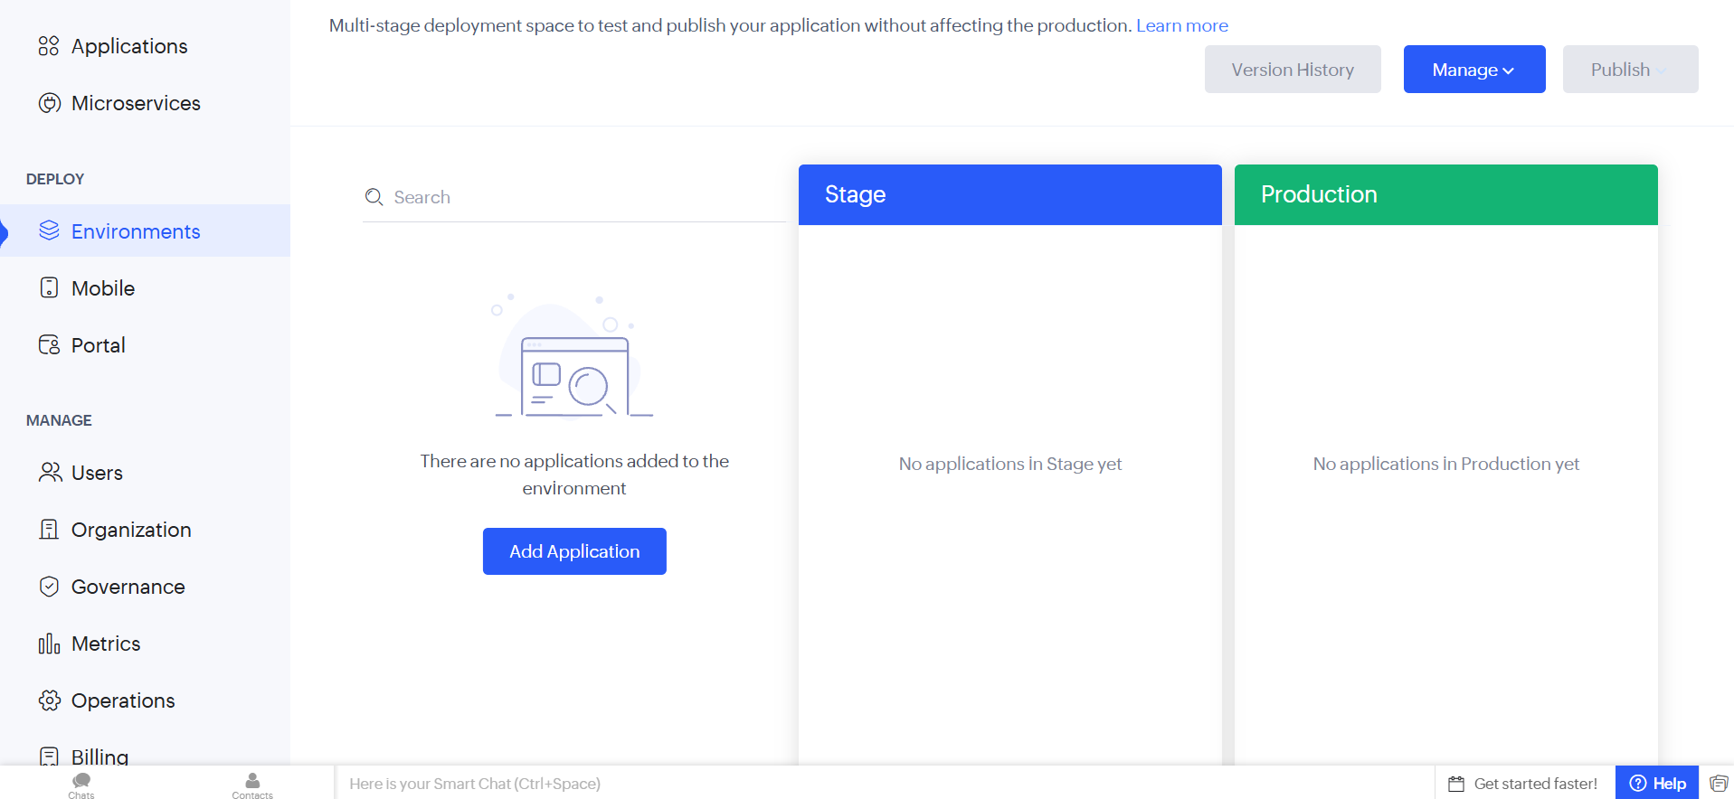
Figure 3: Environments screen in Zoho Creator

Mobile
The Mobile section, also part of Deploy, is where Zoho Creator automatically adapts an application's layout for phones and tablets without requiring any separate mobile development effort. This screen prompts an account upgrade to download the app as a branded mobile application or distribute it through the Play Store or App Store, illustrating that mobile access is treated as a natural extension of the same application rather than a rebuild.
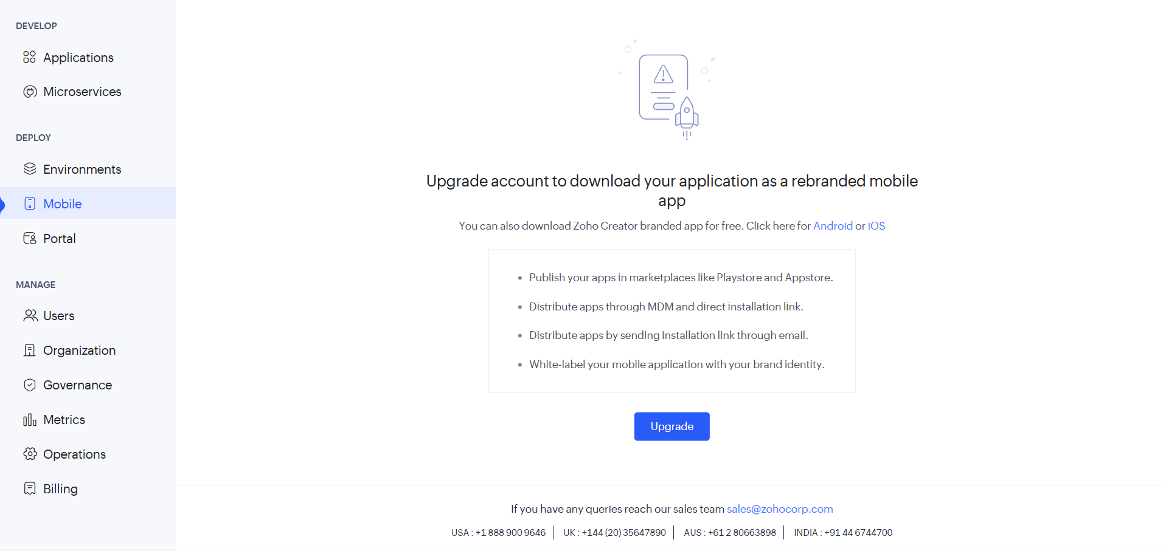
Figure 4: Mobile screen in Zoho Creator

Portal
The Portal screen is the third piece of the Deploy stage. A Portal gives a controlled, branded window into an application for external users — such as customers, vendors, or the public — without exposing internal data or the full administrative interface. Since no portal has been created yet in this account, the screen displays a prompt to "Create Now," marking the starting point for setting up external-facing access.
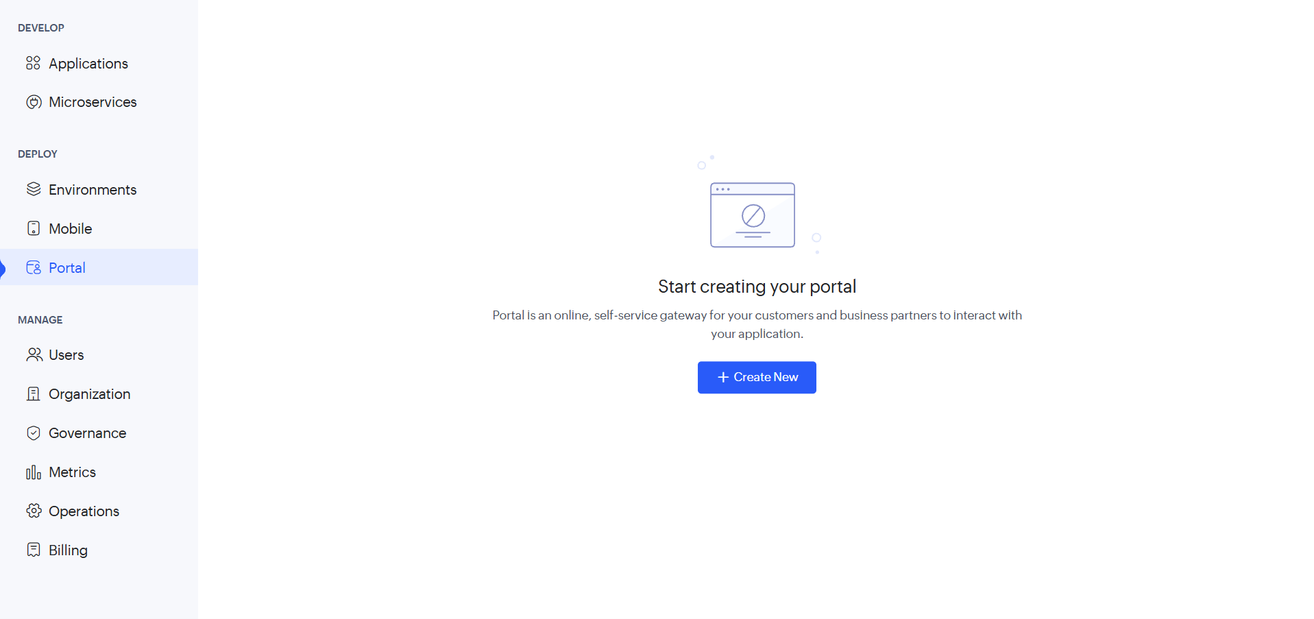
Figure 5: Portal screen in Zoho Creator

Users
Moving into the Manage section, the Users screen lists everyone with access to the account - in this case, the account owner is shown as an active user. From here, administrators can add, remove, and assign roles or permissions to control exactly who can access the application and what they are allowed to do within it

Organization
The Organization screen holds company-wide account details: organization logo and favicon, contact information, super-admin details such as email and phone, and preferences including the organization subdomain and time zone. This is where the account-level identity and configuration of the workspace is defined, separate from any individual application.

Governance
The Governance screen sets compliance rules, data policies, and audit controls for the account. The Security Policies tab shown here allows an administrator to configure security preferences that apply across every application in the organization, helping keep data handling and access consistent and compliant as the account grows.
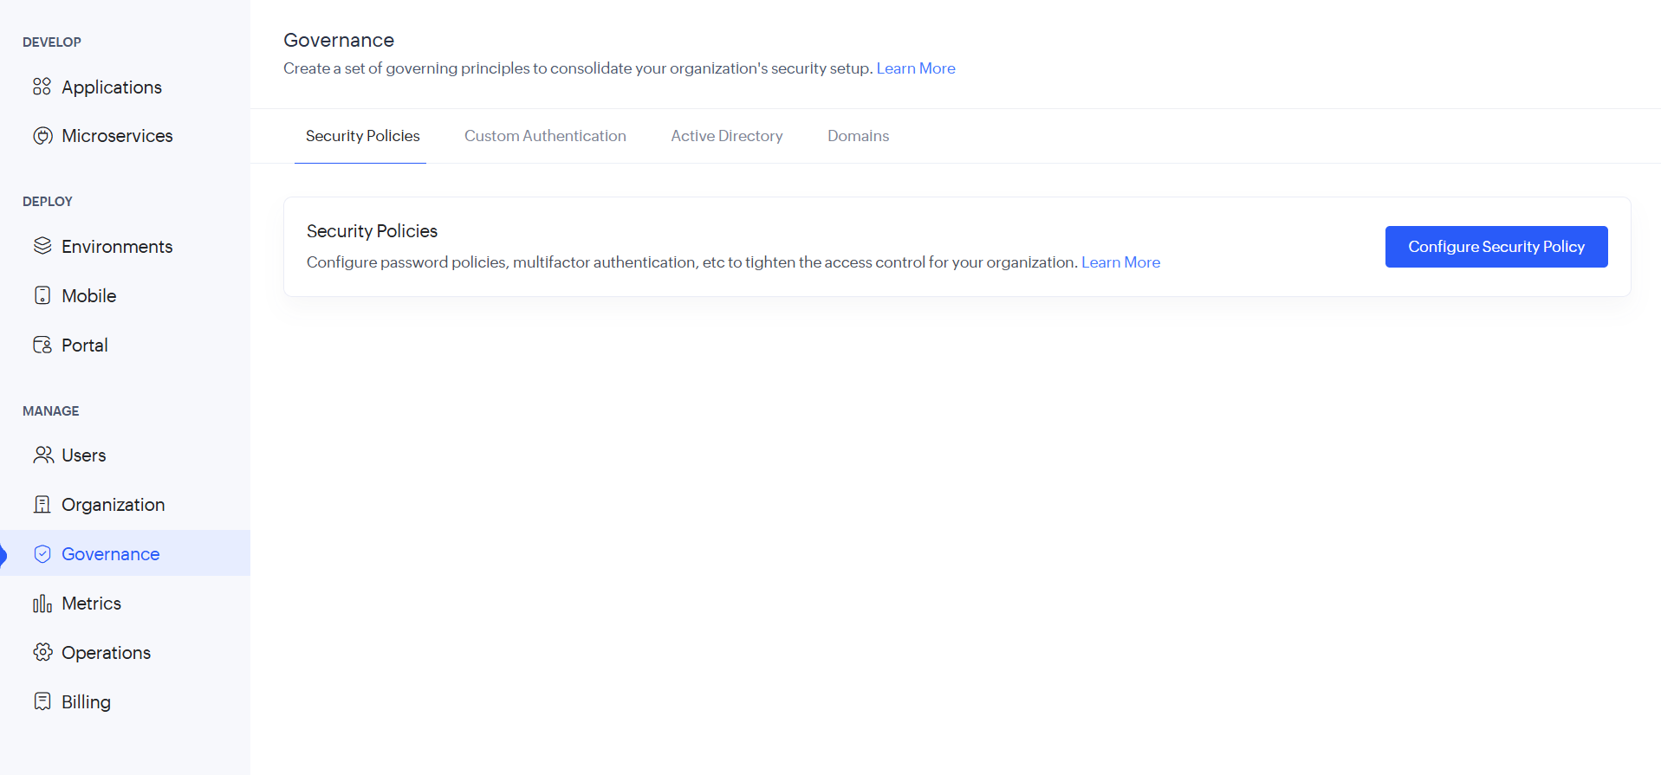
Figure 8: Governance screen in Zoho Creator

Metrics
The Metrics dashboard tracks usage statistics for the account, including applications encountered, live applications, applications followed, and daily average hits per application. Charts for application access trend and integrity check summary are also available, though they show no data yet since the sample application has not been actively used. This section gives administrators visibility into adoption and performance over time.
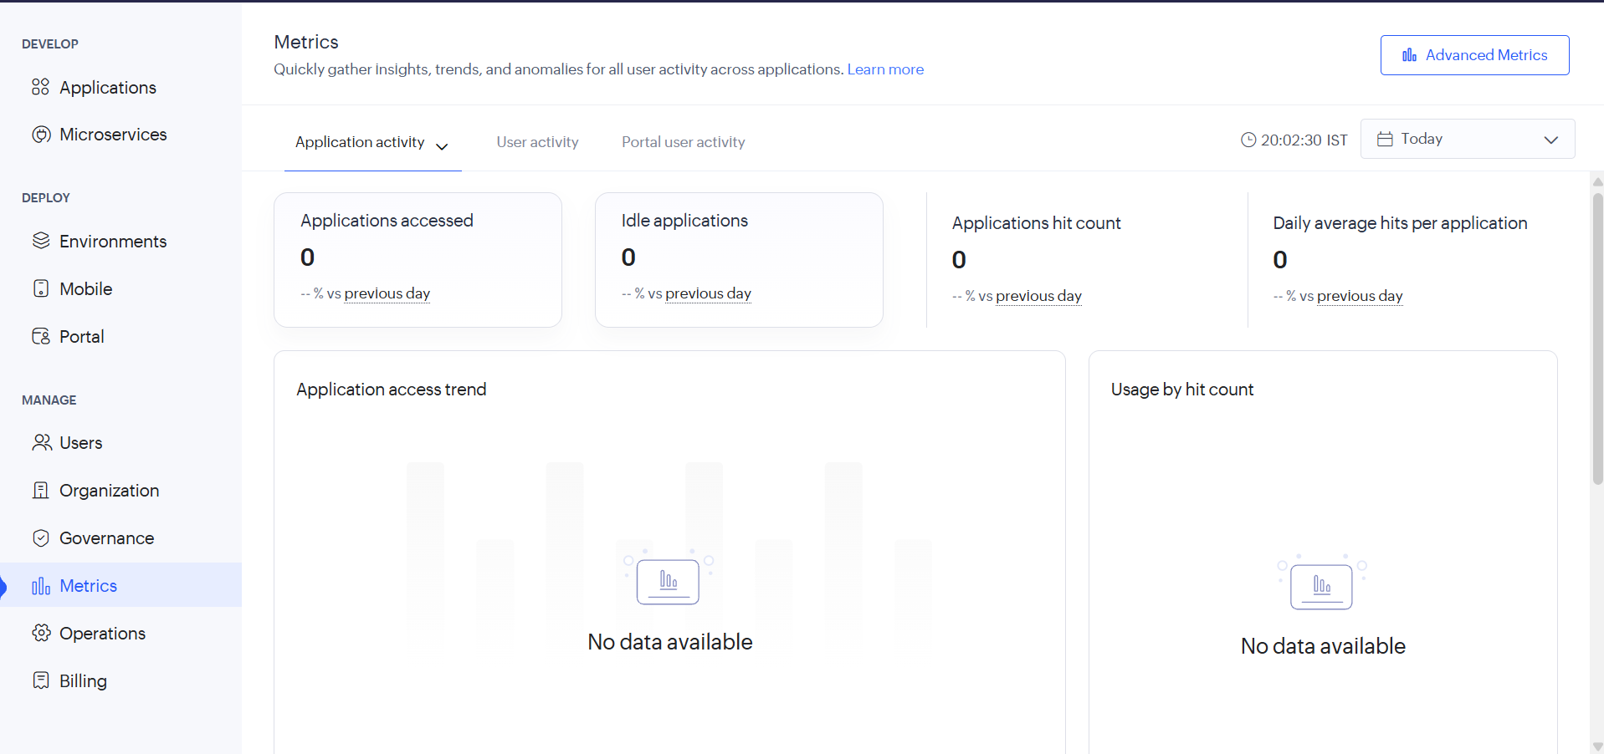
Figure 9: Metrics screen in Zoho Creator

Operations
The Operations screen provides advanced, behind-the-scenes management tools grouped under the Applications category, including backup, audit trail, credit management, domain restriction, and API management on one side, and branch deletion, logs, publish, and form email on the other, alongside support access, system integrations, ZIA, payment gateways, and marketplace tools. This is the control center for maintenance tasks that keep applications running reliably.
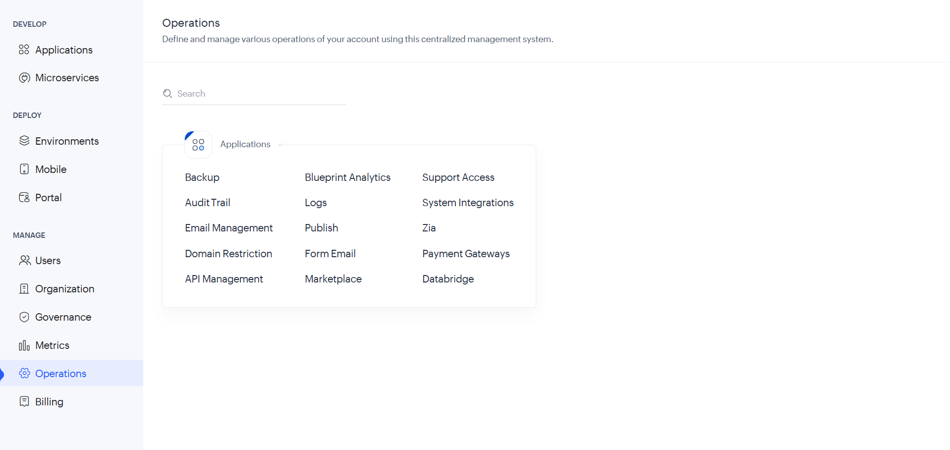
Figure 10: Operations screen in Zoho Creator

Billing
Finally, the Billing screen gives a comprehensive overview of the account's active subscription. This account is shown on a trial plan ending in 15 days, with plan details covering user limits (1 of 10) and app limits (1 of unlimited), plus an option to upgrade. A Usage Details section is also available for monitoring component-level usage, metrics, and custom alerts. Reviewing this screen is a useful last step in account setup, since it confirms what the account is currently entitled to and when action is needed to avoid losing access.
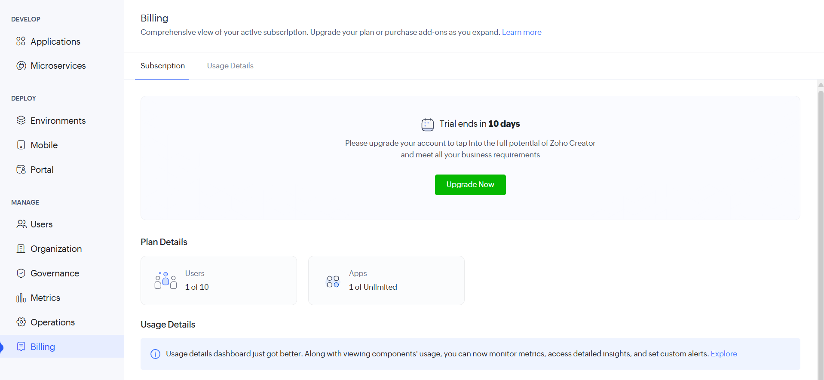
Figure 11: Billing screen in Zoho Creator

Conclusion
This exploration walked through Zoho Creator's account setup and its three core functional areas. The Develop section (Applications and Microservices) is where an application's forms, logic, and reusable components are built. The Deploy section (Environments, Mobile, and Portal) governs how the finished application is released, made available on mobile, and shared with external users. The Manage section (Users, Organization, Governance, Metrics, Operations, and Billing) covers the ongoing administrative responsibilities of running the application securely and within plan limits. Together, these three areas represent the complete lifecycle of a low-code application, from first build to everyday operation.

